📘 PERSONAL PORTFOLIO WEBSITE
Responsive Web Development Project

Submitted by:
Dhanalakshmi Konduru
Role: Full Stack Web Developer
Technologies: HTML5, CSS3, JavaScript

🟦 1. Project Overview
The Personal Portfolio Website is a responsive and professional web application designed to present personal skills, projects, and contact information in an organized and visually appealing manner.
The project follows modern web development practices with a strong focus on responsiveness, accessibility, and clean design.

🟦 2. Project Description
A responsive personal portfolio website showcasing skills, projects, and contact information.
The website is built using HTML5, CSS3, and responsive design principles, ensuring compatibility across mobile, tablet, and desktop devices.

🟦 3. Project Objectives
The objectives of this project are:
- To create a professional online portfolio
- To demonstrate responsive web design skills
- To use semantic HTML5 elements
- To implement layouts using CSS Grid and Flexbox
- To ensure accessibility and user-friendly navigation

🟦 4. Features
- Responsive design for mobile, tablet, and desktop
- Semantic HTML5 structure
- CSS Grid and Flexbox layouts
- Accessible navigation menu
- Contact form with validation
- Hover effects and simple animations

🟦 5. Technologies Used
- HTML5 – For semantic structure
- CSS3 – For styling and responsive layouts
- JavaScript – For basic interactivity
- Git – For version control

🟦 6. Setup and Installation Instructions
To run the project locally:
- Download or clone the project repository
- Extract the project files if downloaded as a ZIP
- Open the index.html file in any modern web browser
- Maintain the original folder structure for proper functionality

🟦 7. Code Structure Explanation
The project follows a structured folder organization:
- index.html – Main webpage structure
- css/ – Contains external CSS files
- js/ – JavaScript files for interactivity

🟦 8. Key Technical Requirements Met
The following technical requirements have been successfully implemented:
- HTML5 semantic elements (header, nav, main, section, footer)
- External CSS files with organized styles
- Responsive design using media queries
- Layout implementation using CSS Grid and Flexbox
- Contact form validation using HTML5 attributes
- Accessible navigation
- Hover effects and animations

🟦 9. Explanation of How Technical Requirements Were Met
- Semantic HTML5 tags were used to improve accessibility and structure
- External CSS files were used to maintain clean and reusable styles
- Media queries ensure responsiveness across different devices
- CSS Grid was used in the projects section
- Flexbox was used in the skills section
- Form validation was implemented using HTML5 input types and required attributes

🟦 10. Screenshots of Working Application
Below are screenshots demonstrating the working application:
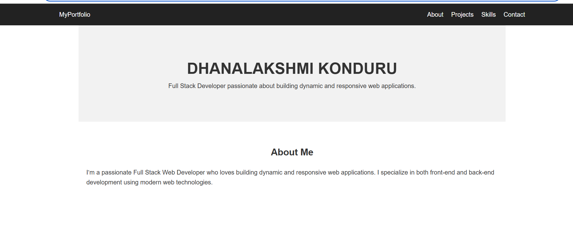
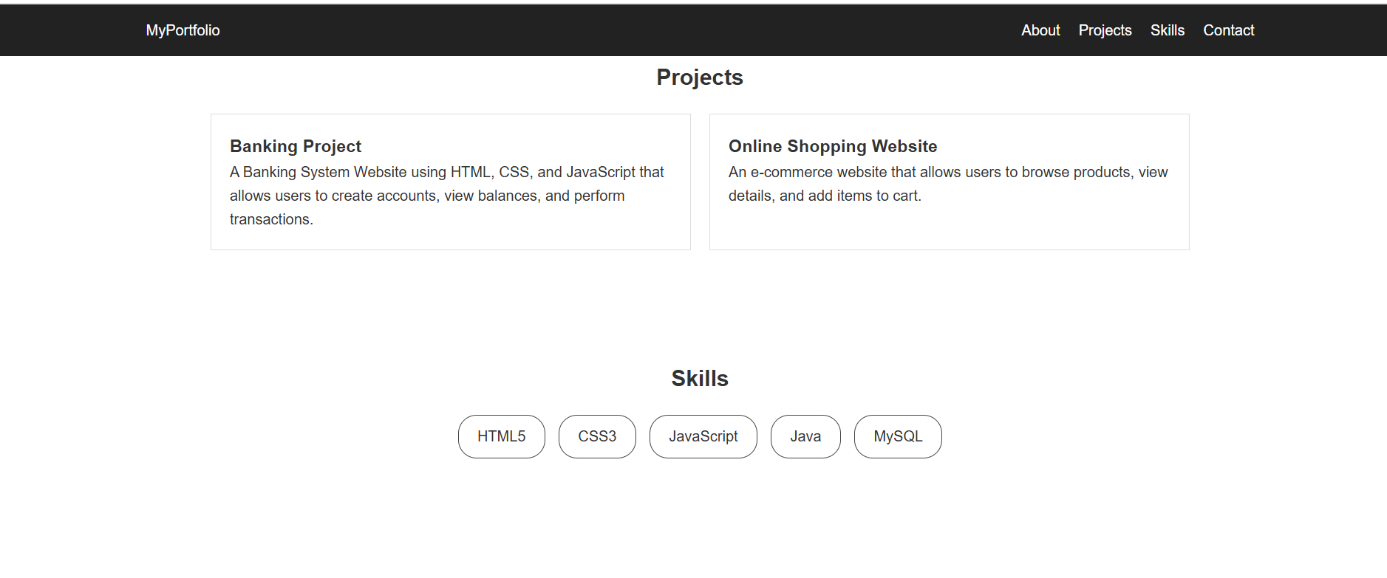
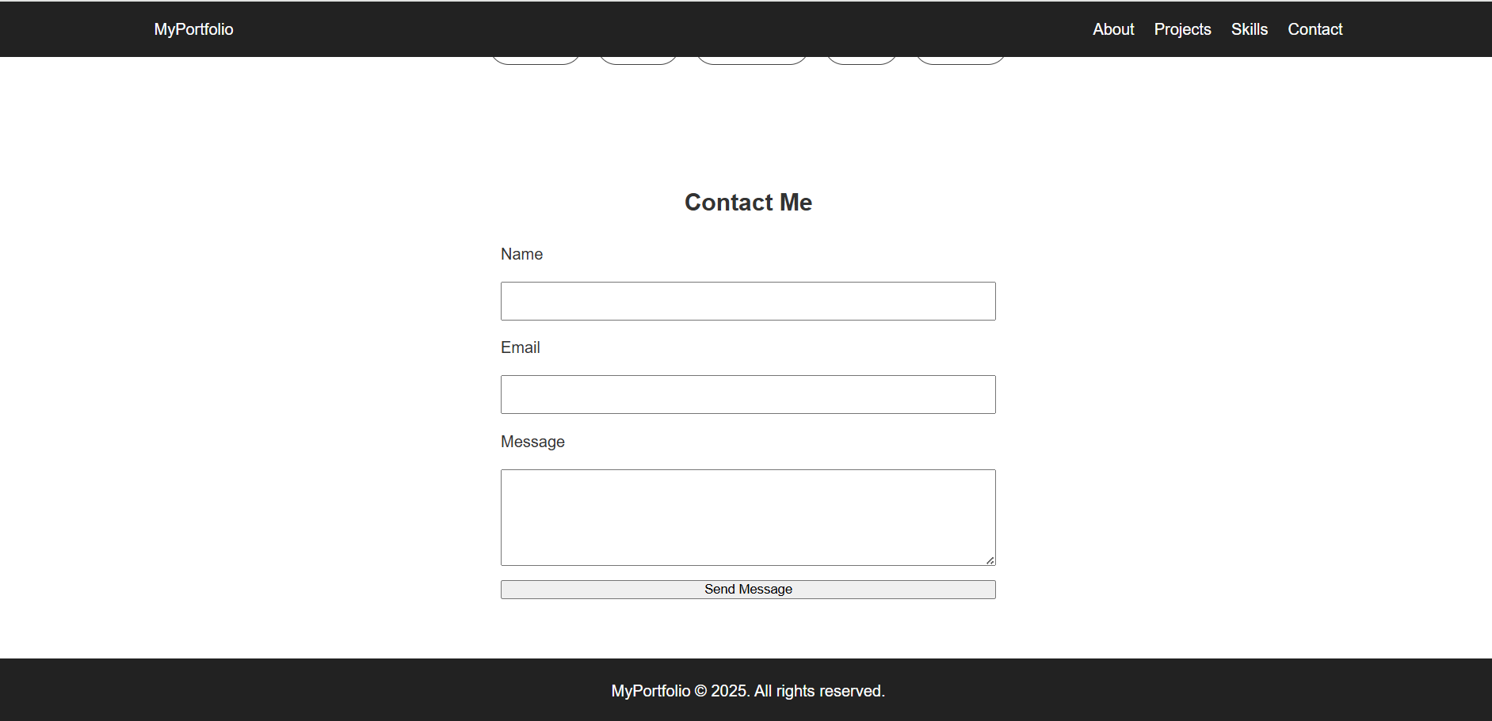

🟦 11. Conclusion
This project successfully demonstrates the implementation of a responsive and accessible personal portfolio website using modern web technologies.It fulfills all the required technical and functional requirements and provides a strong foundation for showcasing professional skills online.

